PRABHAT SINGH- TASK SET 1.

**dBi-:** Decibels(dB) is the unit of Antenna Gain, antenna gain means the ratio of radiation intensity of antenna in a particular direction with that if the power radiated by the antenna is accepted isotropically. Higher gain means how well the conversion is done by the antenna that is for receiving antenna higher gains means the conversion from input signals to the radio waves and vice versa for the transmitter antenna. dBi means decibels relative to an isotropic antenna. There are other units of gain as well such as dBd that is decibels related to the dipole antenna.

**Difference Between Monopole and Dipole Antenna-:**

Monopole and Dipole antenna mainly differ from each due to the radiation mechanism in monopole antenna there’s just one oscillator or signal generator and the other part of the signal is generated through the reflections with the ground plane.

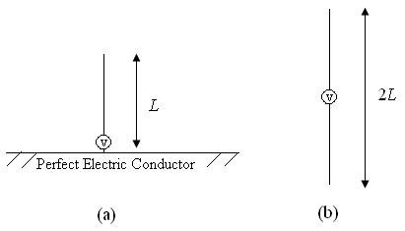

Where as in dipole antenna the signal generators are placed at 180 degrees with each other.

Also the length of the monopole antenna is half the length of the dipole antenna and it provides **HIGH DIRECTIVITY** . Also the impedance is half as of dipole antenna.

**Fundamental Parameters of antenna-:**

1. Impedance Matching-: Impedance matching means the approximate impedance at receiver should match over the transmitter end and vice versa. Reason for impedance matching is to get the maximum power transfer.
2. Bandwidth-: Bandwidth means the range of frequencies antennas can receive and transmit . Higher Bandwidth means it can operate on a wide range of frequencies. Thus providing user variety of options to operate. Also high bandwidth means that files will upload and download much faster.
3. Antenna Effiecieny- It is the ratio of power output to the power input. A high gain antenna is preferred.
4. Gain -: A higher gain antenna means it receives a higher power signal input than the low power input…a higher power input is necessary to get the clear and proper conversion of the input signal to Radio waves and vice versa. ]
5. Directivity-: Directivity of the antenna means the ratio of maximum radiation intensity of the subject antenna to the radiation intensity of an isotropic antenna. A high directivity means that the signals that antenna can receive and transmit are highly directional also a high directional antenna will offer a  **HIGHER GAIN** .
6. Aperture Efficiency-: Aperture Efficiency of an antenna is the ratio of actual radiating area(effective area) to the physical area. An antenna doesn’t radiate through overall physical area but through the particular area thus it is necessary to consider this factor.

**For Rover Communication I will prefer a higher frequency range for the communication as the operation is taking place in open area soo there is less obstacle hence High frequency won’t loose it’s energy …that it can if it takes place indoors with lots of walls as the penetration of high frequency is less. Also the reason why I would prefer higher frequency is because of high transfer speed and high band width means high download speed and also higher power transmission thus resulting in low video latency. 5.8GHz range will be preferred.**

For antennas it is I will prefer a directional sector antenna of 5 GHz band at the base station and a omnidirectional antenna on the rover. All 5 GHz range.

Ubiquiti airMAX Omni Antena of 5Ghz.

And for directional-:

Air Prism 5GHz, 3X30 degree HD Sector Antenna.

<https://www.ui.com/airmax/airprism-sector/>

Or

Air Max AC Sector Antenna

<https://www.ui.com/airmax/airmax-sector-antenna/>

Between Rubber Ducky and Patch Antenna I will prefer rubber ducky more, because patch antenna has a small bandwidth thus it will affect the transmission rate and quality. Also patch antenna is unidirectional thus it will affect the quality of reception and transmission if placed on rover.

Between array antenna and an array of antenna it will be best to use array of antenna as they provide high gain and also they can handle high power.

One of the single on board PC that we can use is NVIDIA Jetson Nano.

**PCB DESIGNS-:**

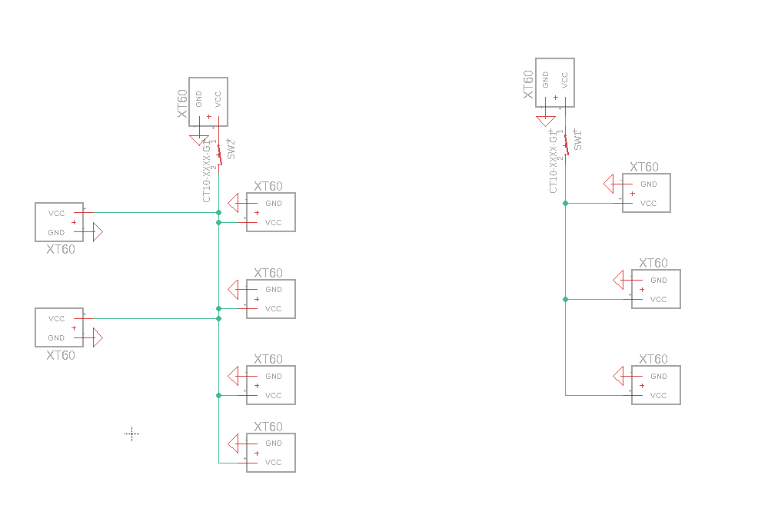

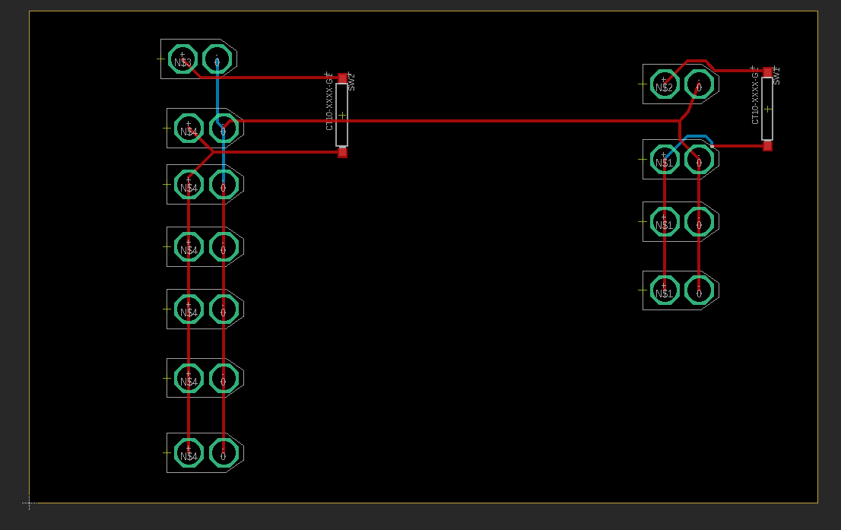Individual kill switch is used for each module soo that other modules can work independently….the main kill switch should be directly connected to the main source…idea was Taken from AGH rover.

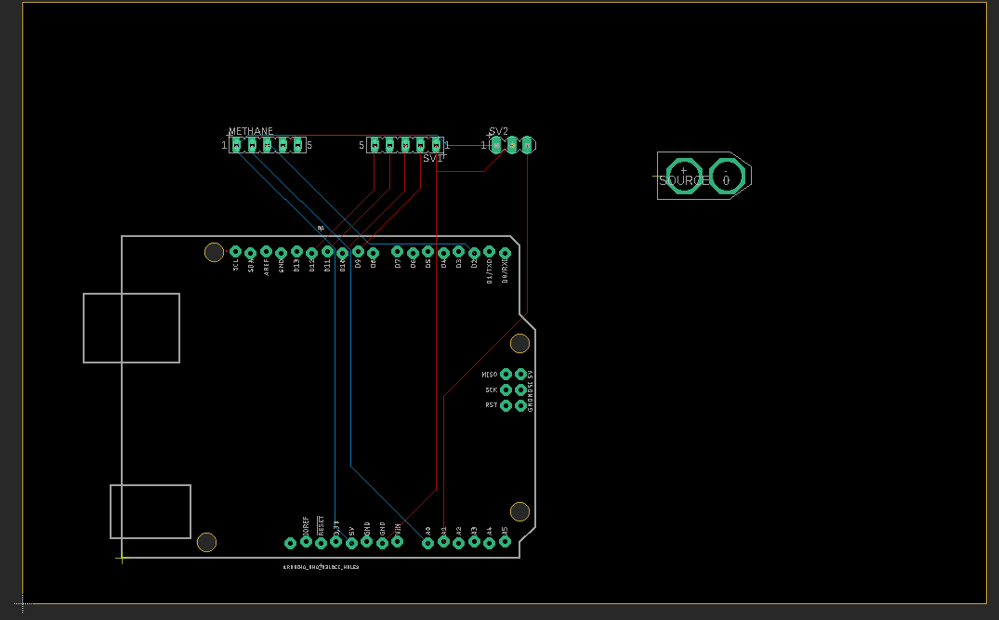

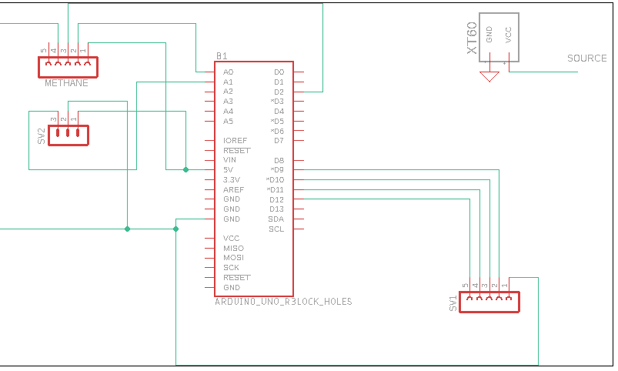

The source in above schematic is used for MDD10A and for the Arduino UNO .